Copenhagen Microsurgery Course

Using a small animal model
This is an intensive three-day practical course to learn the key skills and intricate techniques of microvascular surgery.

September 18-20, 2024, from 9:00 am – 5:00 pm

Social dinner: September 19, 2024

Target audience
The course is designed to impart technical skills for surgeons who want to practice clinical microvascular surgery. It is aimed at surgical specialists and specialists in training, with or without previous microsurgical experience. This includes plastic surgeons, hand surgeons, orthopedic surgeons, neurosurgeons, vascular surgeons, and urological surgeons.

Course setup
Each participant is provided with an independent operating microscope, instruments, and sutures. The emphasis during the course is on practical training in an in-vivo model (rat model). The course is conducted in English by multiple instructors, who closely monitor the practical sessions and provide continuous one-on-one guidance to the participants.

Teaching Faculty
The teaching faculty will comprise of microsurgeons and laboratory technicians who regularly use microsurgical techniques. This ensures participants will receive optimal guidance throughout the course.

Course Objective
- Understand the basics of microsurgery techniques
- Perform basic microvascular anastomoses (end-to-end arterial, end-to-end venous, end-to-side vascular anastomosis and interpositional vein grafts)
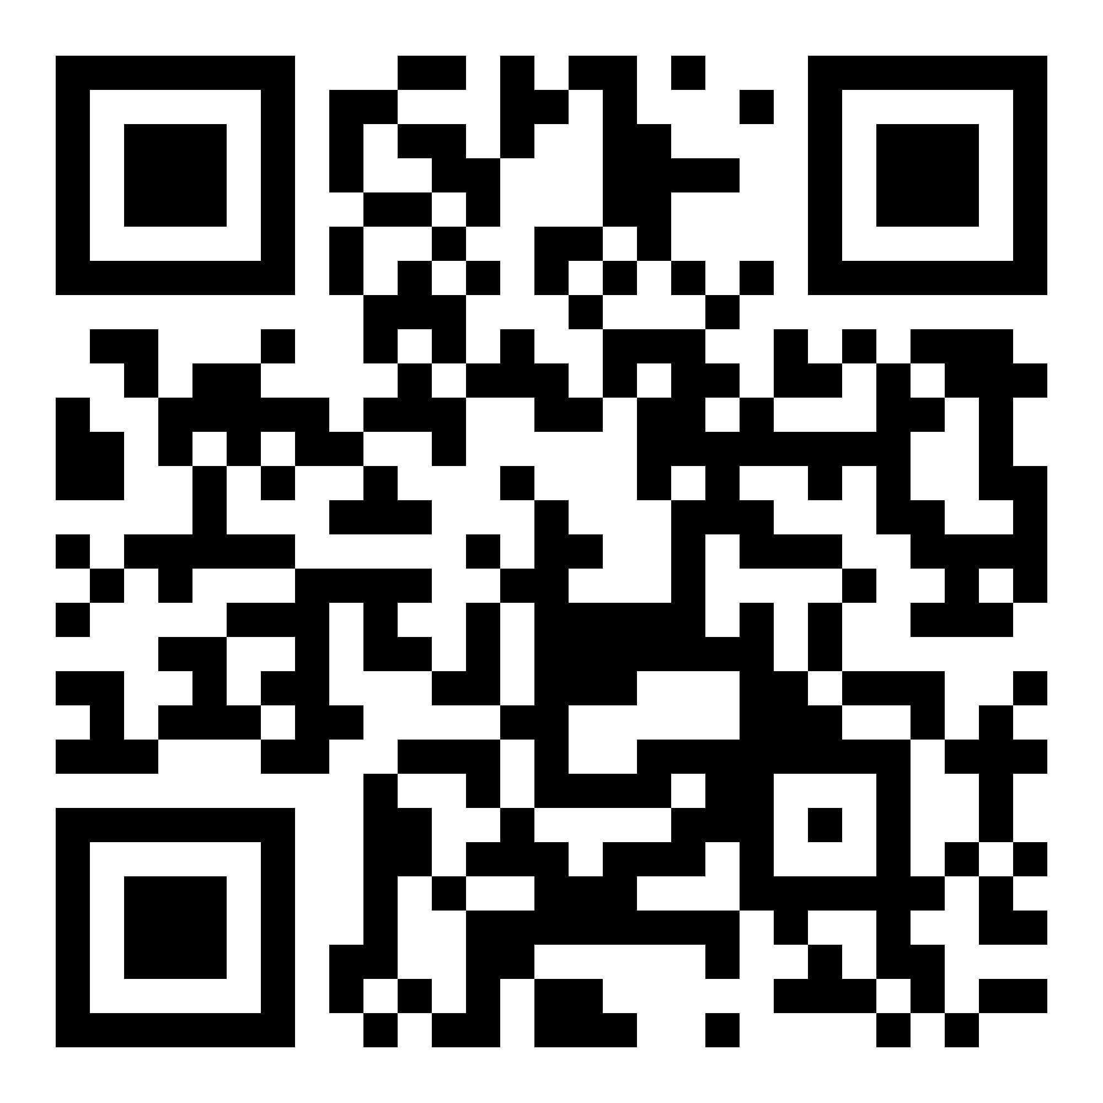
- Understand the basics of nerve repair (optional)
- Perform nerve coaptation (optional)
- Perform free flap transfer in a rat model (optional)

Registration via QR:
Course director
Klas Abelson, Professor, PhD
Department of Experimental Medicine, University of Copenhagen

Teachers
Taiba Alrasheed, Microsurgeon
Department of Plastic and Reconstructive Surgery, Zealand University Hospital

Lea Juul Nielsen, Microsurgeon
Department of Plastic and Reconstructive Surgery, Copenhagen University Hospital

Peter Fryd Birkeland, Microsurgeon
Department of Neurosurgery, Copenhagen University Hospital

Assisting teachers
Rami Mossad Ibrahim, Plastic Surgeon
Department of Plastic and Reconstructive Surgery, University Hospital Herlev

Trine Schønfeldt, MD, PhD-student
Leo Foundation Skin Immunology Research Center, University of Copenhagen

Available spots
12 participants

Workload
Course material will be sent out a month in advance.

We will start every morning with a plenary session continued by practical exercises. The course is a hands-on course with individual work under the microscopes with supervision by the instructors.

Place
University of Copenhagen, Frederiksberg Campus, Dyrlægevej 45, DK-1870 Frederiksberg

Price
The fee for the three-day course is 850 EUR* + social dinner additional fee 50 EUR (optional)
*The fee is including lunch, coffee, tea, afternoon snack and beverage

Registration
https://emed.ku.dk/courses/microsurgery-for-surgeons/.

